# Milestone - 3 - Wipro NGA .Net Fullstack Angular

Name: Souvik Pradhan Date:30-08-2025

## 1. Introduction

This project is a Role-Based Product Management System developed using ASP.NET Core MVC. The application ensures secure registration, login, and role-based authorization using ASP.NET Identity. It supports two roles: Admin and Manager. Security is enhanced with HTTPS, CSRF protection, and Data Protection APIs.

## 2. Features Implemented

* Secure Registration and Login with ASP.NET Identity
* Password Policies (min length, uppercase, special characters)
* Role Management using UserManager and SignInManager
* Role-Based Authorization (Admin: Create, Edit, Delete; Manager: Edit, View)
* Product CRUD with restrictions based on roles
* HTTPS, AntiForgeryToken, and Data Protection API

## 3. File Structure

ProductManagementApp/  
│── Controllers/  
│ ├── AccountController.cs  
│ ├── ProductController.cs  
│── Models/  
│ ├── ApplicationUser.cs  
│ ├── Product.cs  
│── Data/  
│ ├── ApplicationDbContext.cs  
│── Views/  
│ ├── Account/  
│ │ ├── Register.cshtml  
│ │ ├── Login.cshtml  
│ ├── Product/  
│ │ ├── ProductList.cshtml  
│ │ ├── CreateProduct.cshtml  
│ │ ├── EditProduct.cshtml  
│── Program.cs  
│── appsettings.json

## 4. URLs and Expected Outputs

🔹 URL: /Account/Register  
Expected Output: Registration page with Username, Password, and Role fields.  
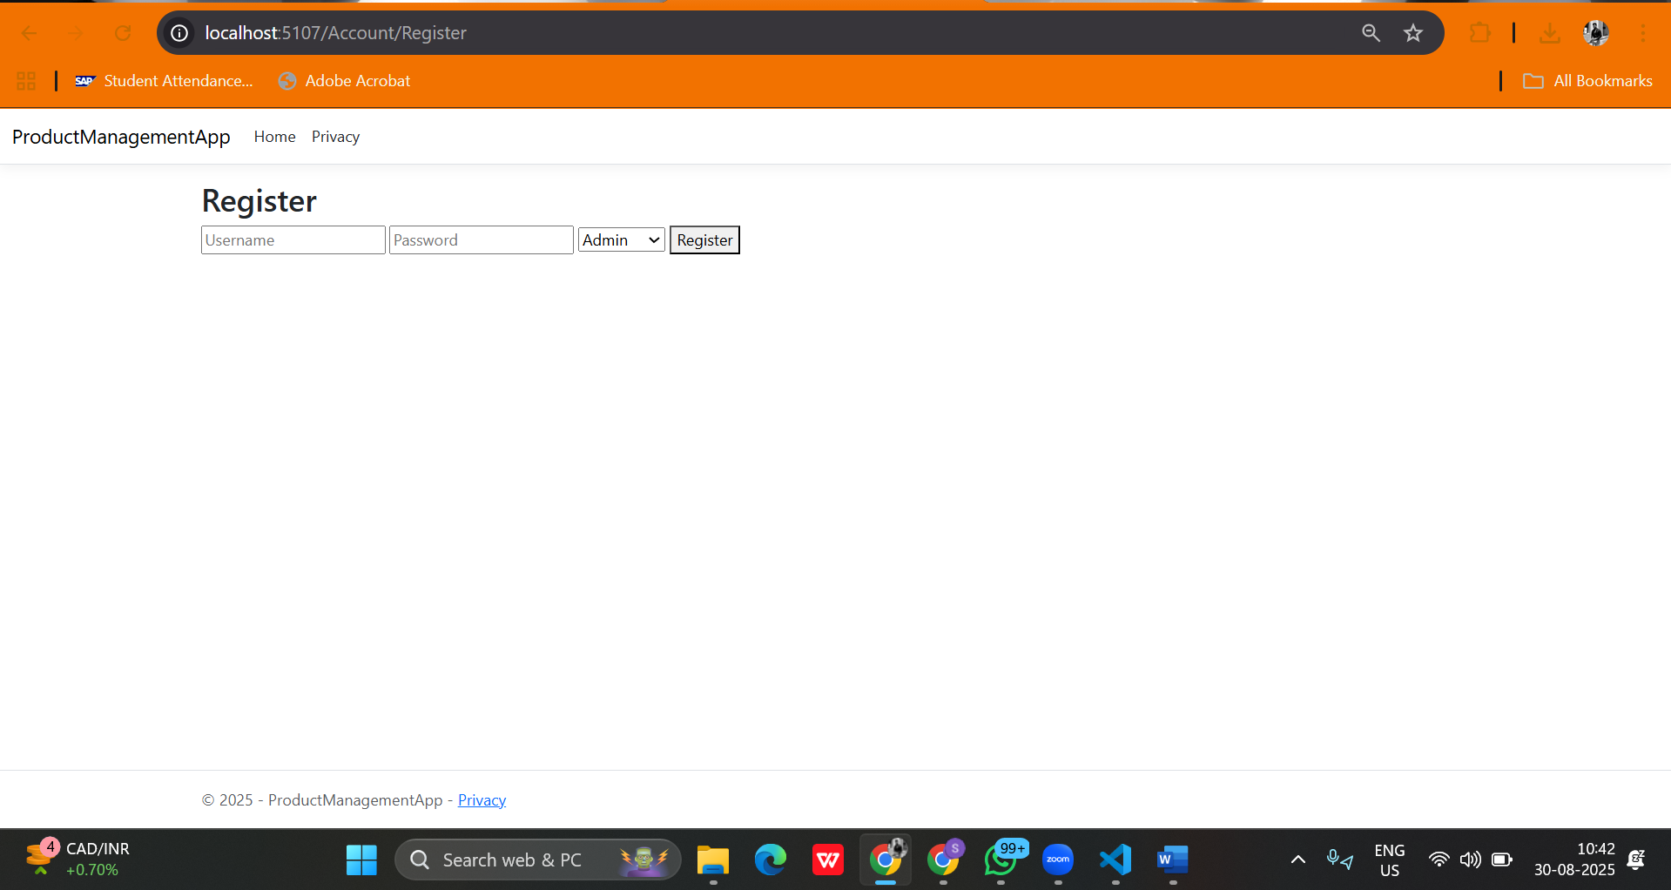

🔹 URL: /Account/Login  
Expected Output: Login page for registered users.  
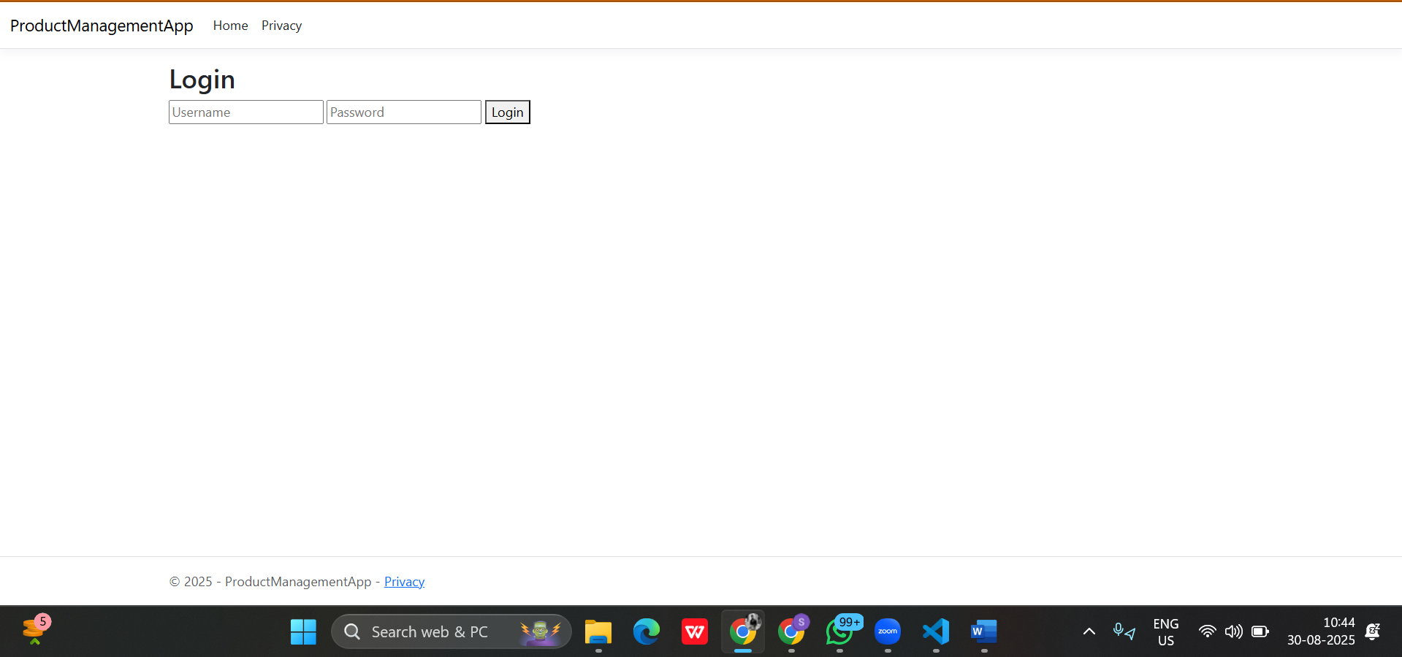

🔹 URL: /Product/ProductList  
Expected Output: List of products with actions (Edit/Delete) based on user role.

**For Admin-:**

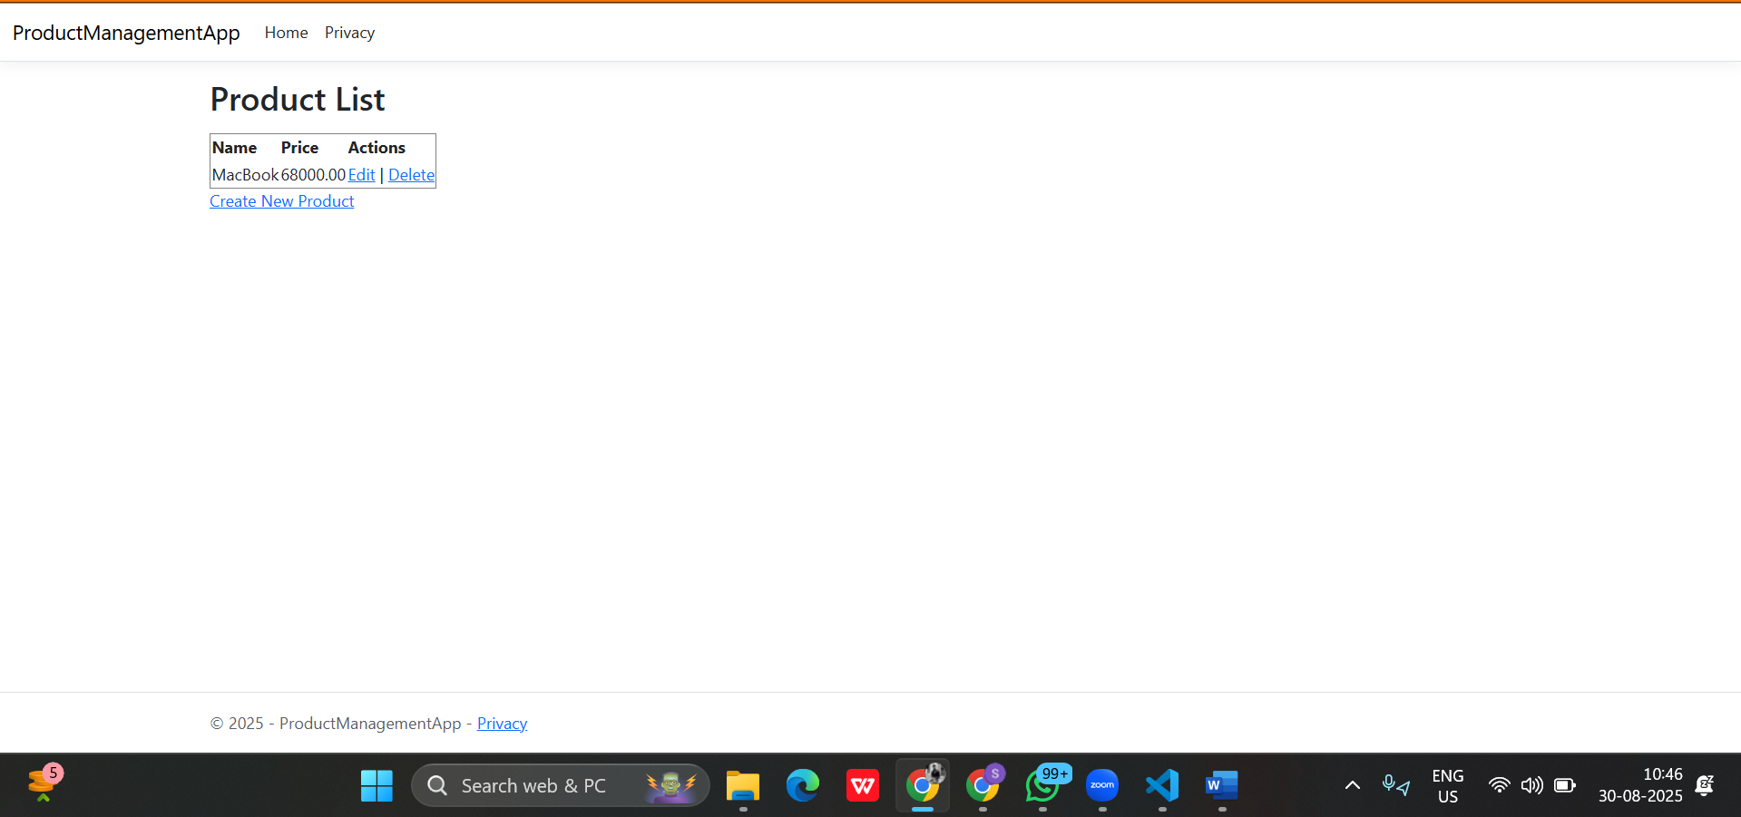

**For Manager**-:

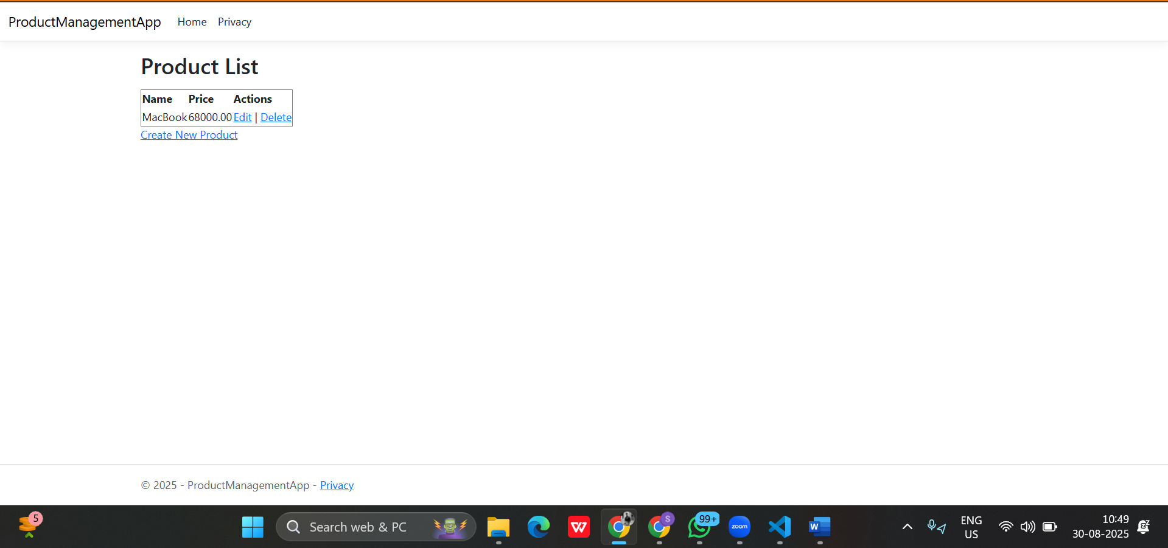

If the **manager** clicks the **Create New Product** it will show access denied**.-:**

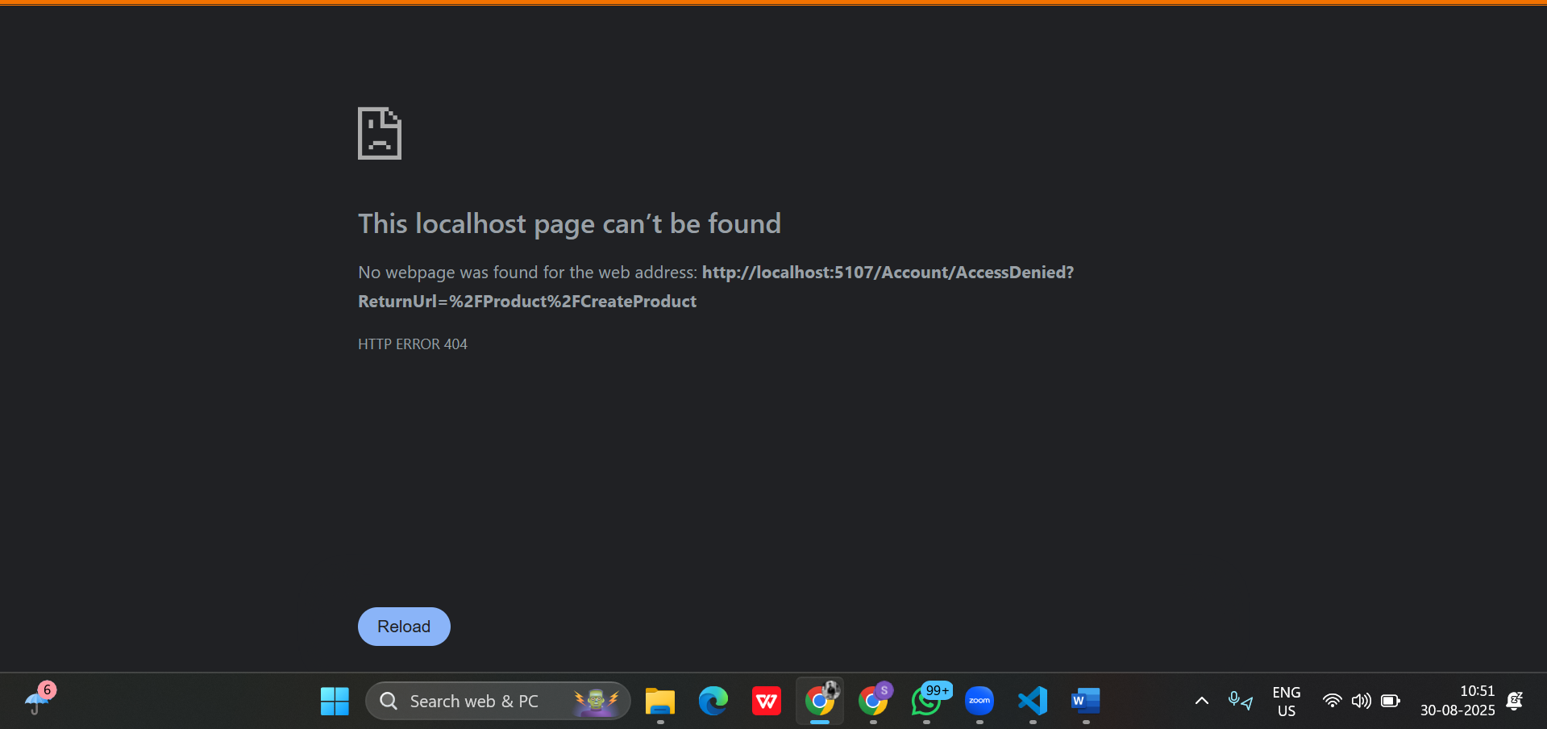

🔹 URL: /Product/CreateProduct (Admin only)  
Expected Output: Form to add a new product. Success message after creation.  
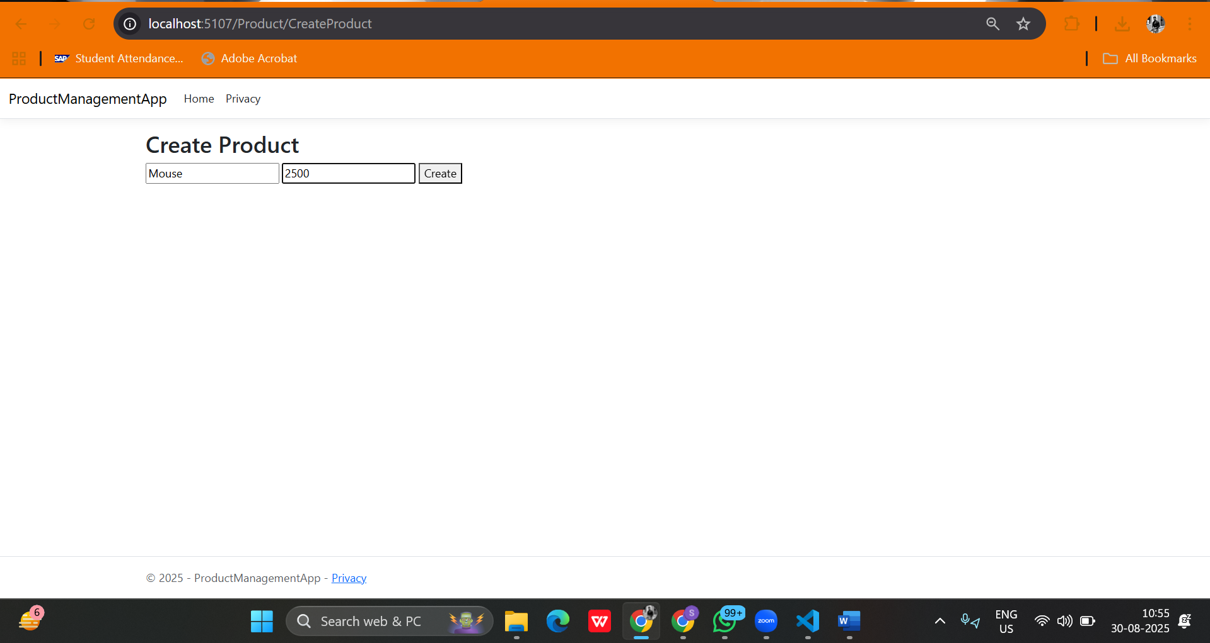

After clicking **Create**-:

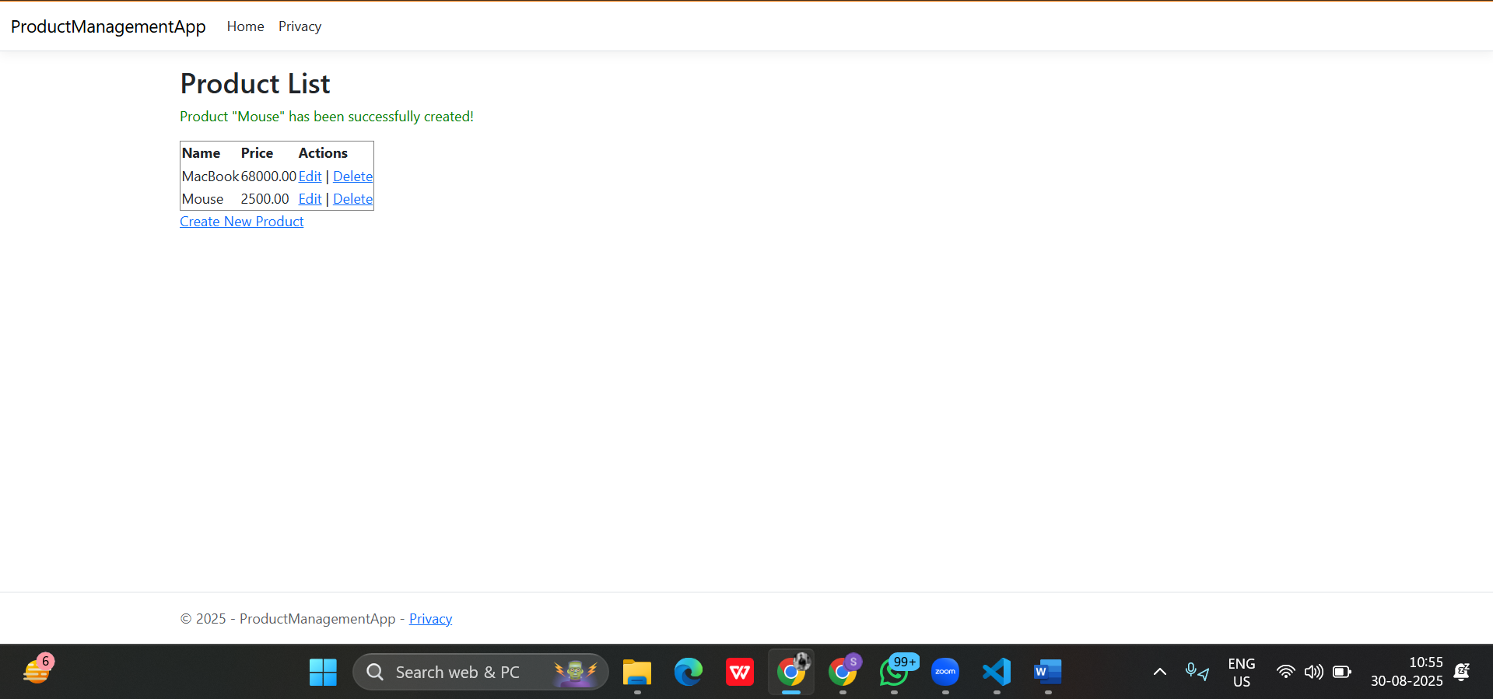

🔹 URL: /Product/EditProduct/1 (Admin & Manager)  
Expected Output: Edit product details and save changes.  
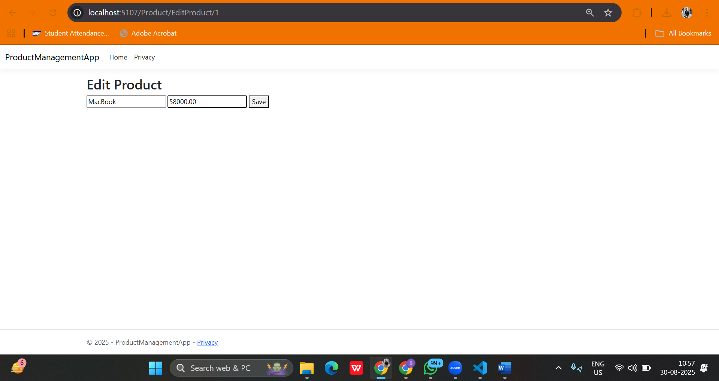

After clicking **Save-:**

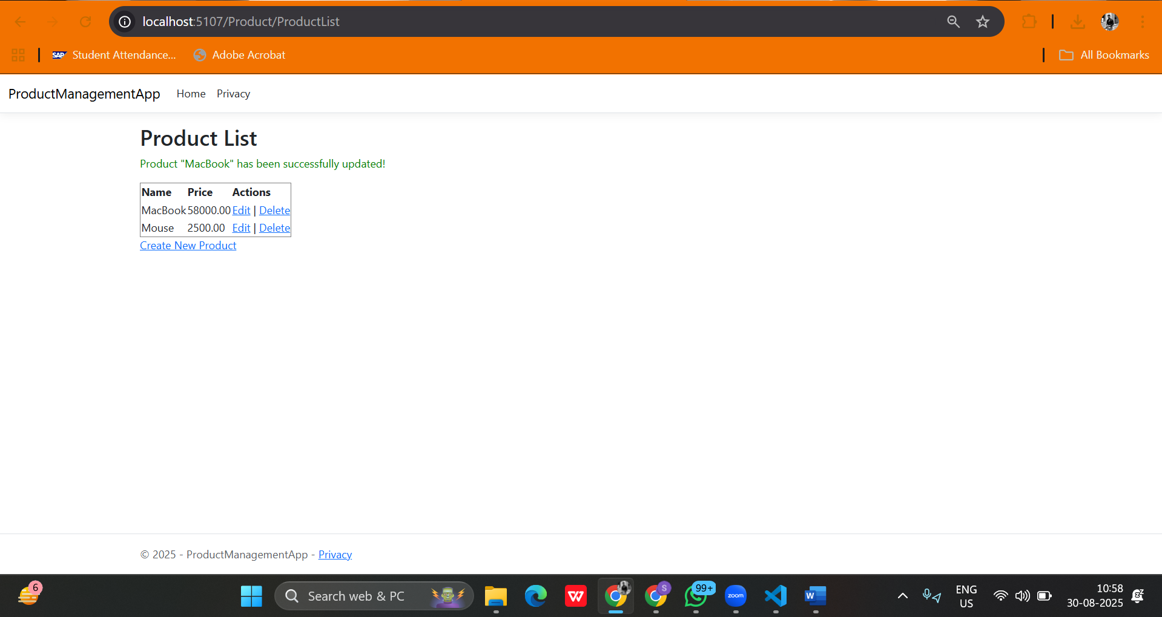

🔹 URL: /Product/Delete/1 (Admin only)  
Expected Output: Product deleted successfully. Manager sees Access Denied.  
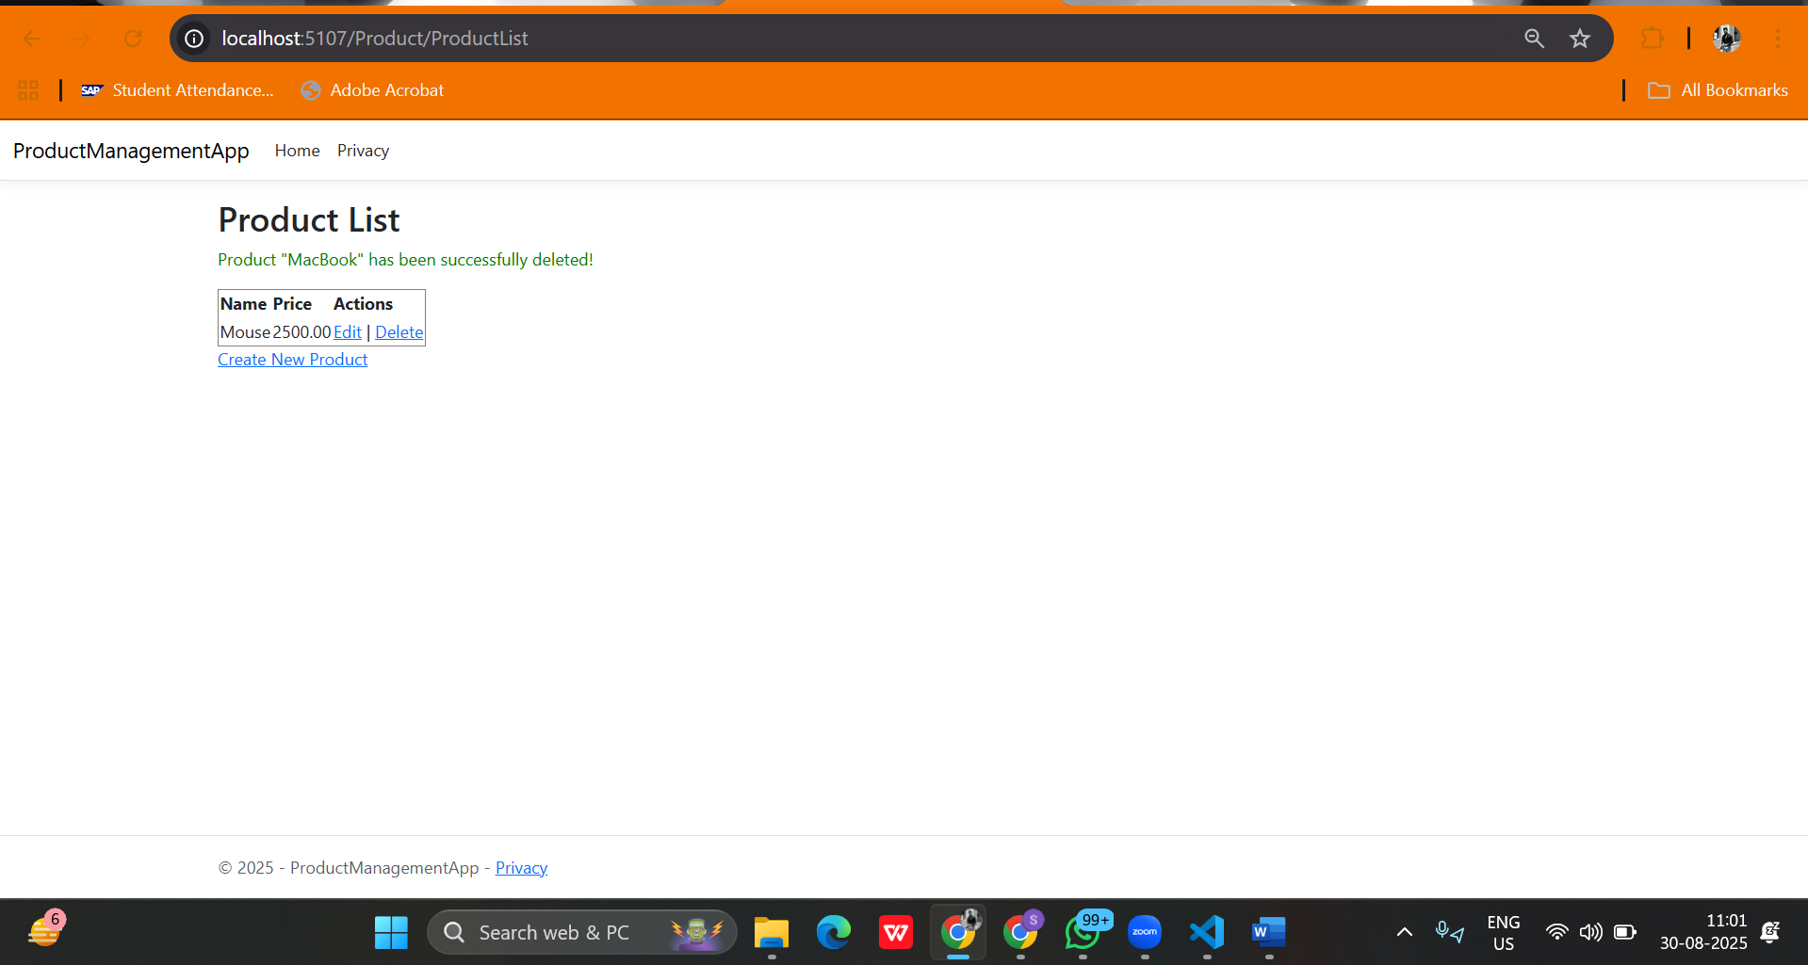

If the **manager** clicks **Delete**-:

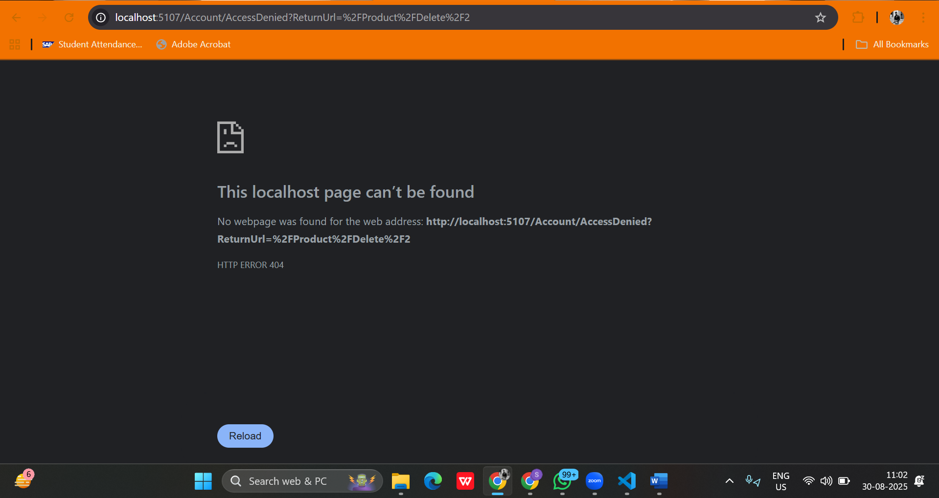

## 5. Security Implementations

* Enforced password policy with uppercase, special characters, and minimum length.
* HTTPS enabled for secure communication.
* AntiForgeryToken applied to all forms for CSRF protection.
* Data Protection APIs used for handling sensitive data like product prices.

## 6. Conclusion

The project successfully demonstrates secure authentication, role-based authorization, and protected CRUD operations in ASP.NET Core MVC. Admin and Manager roles are properly restricted, and security measures like HTTPS, CSRF protection, and data protection are implemented.

# Thank You